***COMPILATION OF HWs:***

### [**Special HW 3&4**](https://blackboard.iit.edu/webapps/assignment/uploadAssignment?content_id=_1268971_1&course_id=_133602_1&group_id=&mode=view)

***HW3: L5 - page 3***

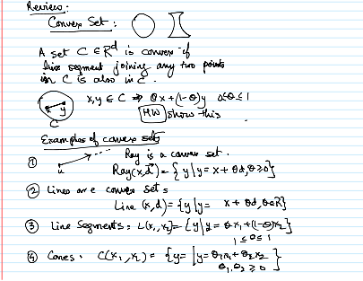

***Statement:***

Let z be a point on the line segment joining x and y, where z = (1-t)x + ty for some scalar t between 0 and 1. Show that a set C in Rd is convex if the line segment joining any two points of C is also in C.

***Solution:***

In order to show this, we have to show that the line segment joining any two points of C is entirely in C. Therefore, we have to show that z is also in C. Since C is a convex set, we know that the line segment joining any two points p and q of C is entirely in C. For example, if we take p = x and q = y, we know that the line segment joining x and y is entirely in C.

Now let us think of the line segment joining x and z. From the definition of z, we know that the line segment joining x and y is entirely in C. For example, if we take p = x and q = y, we know that the line segment joining x and y is entirely in C.

Now let's think about the line segment joining x and z. From the definition of z, we know that z is in z. We can deduce that z is also in C, since z is in the line segment joining x and y, and both line segments joining x and z and y and z are entirely in C.

Therefore, C is a convex set. Since z lies on the line joining x and y and the lines joining x and z; and y and z are entirely in C, we can show that y and z are also entirely in C.

In conclusion, we have shown that C is a convex set if the line segment joining any two points of C in Rd is also in C.

***HW4: L5 - page 4***

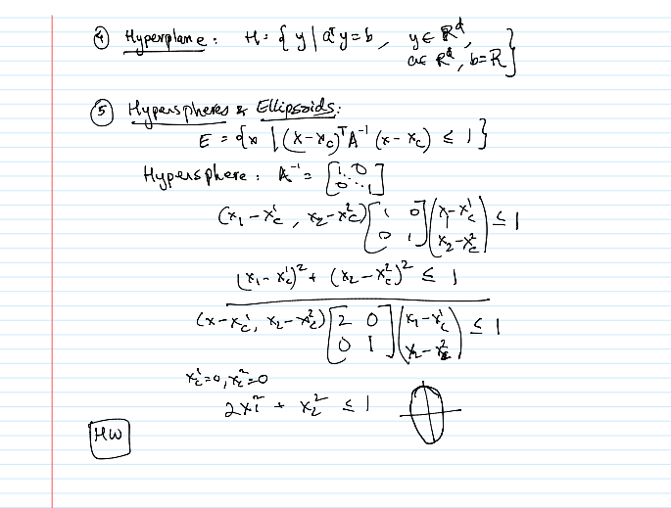

***Statement:***

Show that the next spaces are convex:

***(i) Lines.***

***(ii) Line segments in Rd***

***(iii) Cones***

***(iv) Hyperspheres & Ellipsoids.***

***(v) Hyperplanes***

***Solution:***

***General definition of convex:***

A set S is convex if for every pair of points x, y in S, the line segment joining x and y is also in S.

***(i) Lines.***

To prove that straight lines are a convex set, we first have to define what we mean by a straight line. In geometry, a line is an infinitely long, straight collection of points extending in both directions without end. A line can be represented mathematically by an equation of the form y = mx + b in two dimensions or by an equation of the form ax + by + cz = d in three dimensions, where m, b, a, b, c and d are constants.

To prove that lines are a convex set, we have to show that given any two points on the line, every point on the line segment joining them lies on the line. Suppose we have two points P and Q on the line. We can represent these points by their coordinates as P = (x1, y1) and Q = (x2, y2) in two dimensions or P = (x1, y1, z1) and Q = (x2, y2, z2) in three dimensions.

Let R be a point on the line segment PQ, represented by the coordinates (tx1 + (1-t)x2, ty1 + (1-t)y2) in two dimensions or (tx1 + (1-t)x2, ty1 + (1-t)y2, tz1 + (1-t)z2) in three dimensions, where t is a scalar between 0 and 1. We need to show that R is also on the line.

To do this, we can substitute the coordinates of R into the equation of the line and see if the equation holds. For the two-dimensional case, the equation of the line is y = mx + b, so we have:

ty1 + (1-t)y2 = m(tx1 + (1-t)x2) + b.

Expanding the equation, we obtain

ty1 + y2 - ty2 - y1 = mtx1 + mx2 - mt x2 + mb - b

Simplifying, we obtain:

y1 - mx1 - b + y2 - mx2 - b = (y1 - mx1 - b)t + (y2 - mx2 - b)(1-t).

Since P and Q are on the line, we know that y1 = mx1 + b and y2 = mx2 + b. Substituting these values in the equation, we obtain:

0 = 0

The equation is valid for any value of t, so R is also on the line. The demonstration is similar for the three-dimensional case, where we can substitute the coordinates of R into the equation ax + by + cz = d and see if it holds.

Thus, we have shown that the lines are a convex set, since every point on the line segment joining any two points on the line also lies on the line.

***(ii) Line segments in Rd***

To prove that the line segments in Rd are a convex set, we have to show that any point on the line segment joining two points of the set also belongs to the set.

Consider two points, x and y, in Rd. Then the line segment joining these two points can be expressed as

z = (1-t)x + ty

where 0 <= t <= 1 is a scalar parameter.

Now, we have to show that any point on this line segment also belongs to the set. Let us take an arbitrary point p on this line segment. Then, p can be expressed as:

p = (1-s)z + su

where 0 <= s <= 1 is a scalar parameter, and u is a point on Rd.

Substituting the value of z into the above equation, we obtain:

p = (1-s)((1-t)x + ty) + su

= (1-s)(1-t)x + (1-s)ty + su

= [(1-s)(1-t)x + (1-s)t y] + su

= (1-st)x + st y + su

Now we have to show that p is also a point of the line segment joining x and y. To do this, we have to show that 0 <= st <= 1. Since 0 <= s, t <= 1, p is a point on the line joining x and y.

Since 0 <= s, t <= 1, we have:

0 <= st <= 1

Therefore, p belongs to the line segment joining x and y.

Since this is true for any point p of the line segment, we can conclude that the line segment in Rd is a convex set.

***(iii) Cones***

Consider a cone and two points, P and Q, inside the cone. It is possible to express the line segment joining P and Q as a linear combination of the two points with a scalar parameter, t, varying between 0 and 1. Since P and Q are in the cone, they can be expressed as a linear combination of the vertex and the generators, denoted by v and G, respectively. Substituting these expressions into the equation of R, we see that R is also a linear combination of v and the generators, which proves that the cone is a convex set. This is because any point on the line segment connecting P and Q is also a linear combination of v and G, and therefore is also on the cone.

***Mathematical development:***

The cone is a convex set, which means that any two points inside the cone can be connected to a line segment that lies completely inside the cone. To demonstrate, P and Q are any two points on the cone. We can express the line segment joining them as R = tP + (1 - t)Q, where t is a scalar parameter between 0 and 1. Since P and Q are in the cone, we know that they can be expressed as linear combinations of the vertices and generators of the cone. That is, P = t1v + (1 - t1)g1 and Q = t2v + (1 - t2)g2, where t1, t2 ≥ 0 and g1, g2 are generators.

Substituting these expressions into the equation for R, we obtain:

R = t(t1v + (1 - t1)g1) + (1 - t)(t2v + (1 - t2)g2) = tt1v + (1 - tt1)g1 + t(1 - t1)g1 + (1 - t)g2 + t2v - t2(1 - t)g2 = (tt1 + t2(1 - t))v + ((1 - tt1)g1 + (1 - t2))g

Since v is fixed and G is a fixed set of rays emanating from v, the expression for R remains a linear combination of v and the generators: R = t3 ∗ v + (1 - t3)g3, where t3 ≥ 0 and g3 is a generator. Hence, the line segment joining P and Q is entirely inside the cone, as well as R. We can conclude that, the cone is a convex set.

***(iv) Hyperspheres & Ellipsoids.***

An ellipsoid is a set of points in which each point satisfies the equation:

(x - c)ᵀA-¹(x - c) ≤ 1

where x is a coordinate vector, c is the center of the ellipsoid, A is a positive definite matrix and ᵀ denotes the transpose.

To prove that the ellipsoid is a convex set, we have to show that for any two points inside the ellipsoid, the line segment joining them is entirely inside the ellipsoid. Consider two points, x₁ and x₂, that satisfy the above inequality:

(x₁ - c)ᵀA-¹(x₁ - c) ≤ 1

(x₂ - c)ᵀA-¹(x₂ - c) ≤ 1.

Let us define a new point, y, as a convex combination of x₁ and x₂:

y = λx₁ + (1-λ)x₂

where λ is a scalar parameter between 0 and 1.

We can express y as:

y = λ(x₁ - c) + (1-λ)(x₂ - c) + c.

Expanding this expression, we obtain:

y - c = λ(x₁ - c) + (1-λ)(x₂ - c)

y - c = λx₁ - λc + x₂ - λx₂ + λc

and - c = λ(x₁ - c) + (1-λ)(x₂ - c)

Multiplying both sides of the above inequality by A-¹, we obtain:

(y - c)ᵀA-¹(y - c) = λ(x₁ - c)ᵀA-¹(x₁ - c) + (1-λ)(x₂ - c)ᵀA-¹(x₂ - c).

Since both x₁ and x₂ lie inside the ellipsoid, the left side of the inequality is less than or equal to 1. Furthermore, since A is positive definite, the right side of the inequality is a convex combination of two non-negative numbers, which is also less than or equal to 1. Therefore, y lies inside the ellipsoid.

Since this is true for any two points inside the ellipsoid, we have shown that the ellipsoid is a convex set. Therefore, as the condition “A set S is convex if for every pair of points x, y in S, the line segment joining x and y is also in S” is met, the Ellipsoids in Rd are convex.

***(v) Hyperplanes: a^T x = b.***

A hyperplane is a subspace of one dimension less than the ambient space. Let H be a hyperplane in Euclidean space, and let u and v be two points in H. The line segment joining u and v can be written as:

w = (1 - t)u + tv

where t is a scalar parameter between 0 and 1. Since H is a subspace, it is closed under linear combinations, so w is also in H. Therefore, the line segment connecting any two points in H lies entirely inside H, and H is a convex set.

***Mathematical development:***

Let H be a hyperplane in n-dimensional space. We can write the equation of H as

a1x1 + a2x2 + ... + anxn = b

where a1, a2, ..., an are constants, and b is a constant.

Suppose we have two points P and Q in H. We can write the coordinates of P as (p1, p2, ..., pn) and the coordinates of Q as (q1, q2, ..., qn). Then, the line segment connecting P and Q can be written as:

R = tP + (1-t)Q

where t is a scalar parameter between 0 and 1.

We can write the coordinates of R as:

r1 = tp1 + (1-t)q1

r2 = tp2 + (1-t)q2

...

rn = tpn + (1-t)qn

Now, let us show that R is also in H. Substituting the coordinates of R into the equation of H, we obtain

a1r1 + a2r2 + ... + anrn = a1(tp1 + (1-t)q1) + a2(tp2 + (1-t)q2) + ... + an(tpn + (1-t)qn)

= t(a1p1 + a2p2 + ... + anpn) + (1-t)(a1q1 + a2q2 + ... + anqn)

= tb + t(0) + (1-t)(0)

= b

Therefore, R is also in H, which means that the line segment joining P and Q is entirely inside H. Therefore, H is a convex set.

This proof shows that any hyperplane in n-dimensional space is a convex set.

***HW5: L6 - page 2***

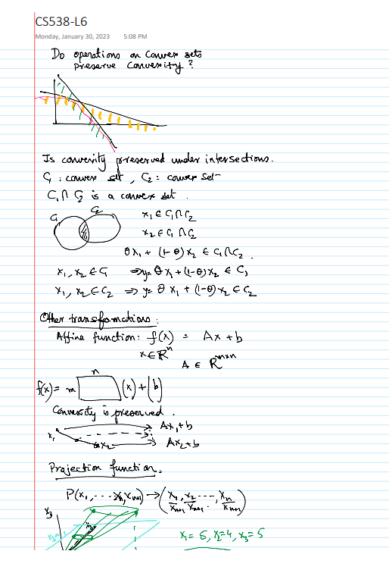

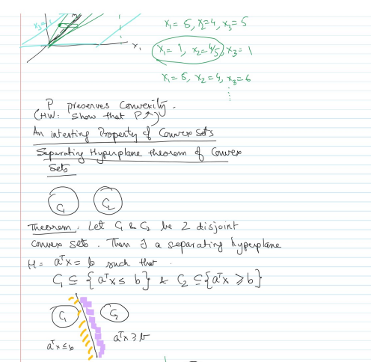

***Statement:***

* Do operations on convex sets preserve convexity?
* Show that the ‘Projection function’ operation preserves convexity

***Solution:***

* ***Do operations on convex sets preserve convexity?***

We must demonstrate that if C and D are two convex sets in Rd, and the following operations result in a convex set, then operations on convex sets preserve convexity.

***Intersection:*** A convex set is formed when C and D meet at their intersection.

If x and y are two points at the intersection of C and D, then they are convex sets in both C and D. Because C and D are convex, the line segment that connects any two points in C or D is also in C or D. As a result, the line segment that connects x and y lies entirely in both C and D, and as a result, it intersects them. As a result, both sets' intersections are convex.

***Union:*** A convex set is formed when two convex sets, C and D, are joined together, and only if C and D are distinct.

Consider the two convex sets C and D. Since C and D are both convex, their union is clearly convex if they are disjoint.

Their union may not be convex if they are not disjoint. Take, for instance, two unit circles in R2 whose centers are located at (0,0) and (2,0). The circles do not convex when they join at two points.

In a nutshell, the intersection of two convex sets keeps being convex, whereas the union of two convex sets keeps being convex as long as they are disjoint. As a result, convexity is maintained by operations on convex sets.

* ***Show that the ‘Projection function’ operation preserves convexity***

In order to prove that the projection operation (P_y) preserves convexity, let C be a convex set in Rd and P_y(x) the projection of x onto the subspace spanned by y. To this end, note that for any x, z and y in Rd, we have ||P_y(x) - P_y(z)|| and ||x - z||. We can show that "𝝺P_y(x) + (1 -𝝺)P_y(z)" also exists in C as follows using this fact:

Let y be any vector in Rd, and let x, z be two points in C. Then they exist:

When we add and subtract "𝝺P_y(x) + (1 -𝝺)P_y(z)" from both sides, we get: P_y(x) - x ⟂ y, and P_y(z) - z ⟂ y.

Rearranging the terms we obtain: P_y(x) - P_y(x) - (1 -𝝺)P_y(z) + P_y(z) - x + 𝝺 x + (1 - 𝝺)z - 𝝺P_y(x) - (1 - 𝝺)P_y(z) ⟂ y

Using the fact that:

|| P_y(x) - P_y(z) || <= || x -z || the distances between points in the subset of projected subspaces are always smaller or equal than the distances in the whole dimensional space

we can show that:

𝝺P_y(x) + (1 - 𝝺) P_y(z) - 𝝺x - (1 - 𝝺) z ⟂ y

Since y is arbitrary, this means that λP_y(x) + (1 - λ)P_y(z) - λx - (1 - λ)z lies in the orthogonal complement of R^d, which is nothing but the singleton {0}. Therefore, we have:

λP_y(x) + (1 - λ)P_y(z) = λx + (1 - λ)z + (λP_y(x) + (1 - λ)P_y(z) - λx - (1 - λ)z) ∈ C

This shows that P_y maintains convexity

***Bonus HW: L6 - page 3***

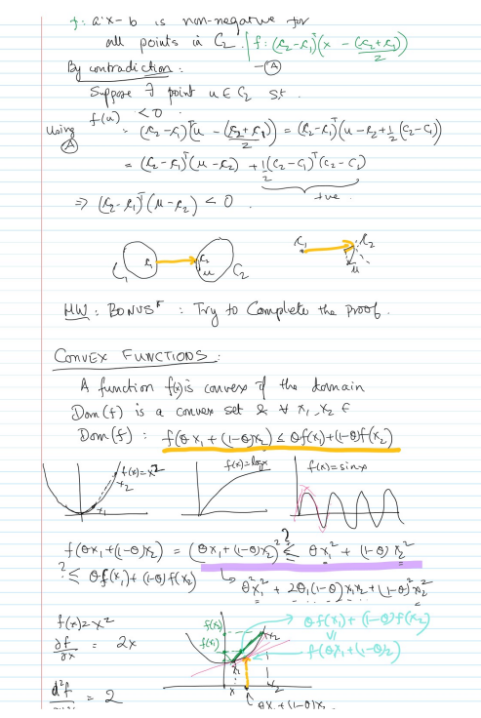

***Statement:***

In this BONUS point, we have been asked to prove by contradiction that given points c1, c2 such that they belong to two different convex sets C1 and C2, there is a point that contradicts that you have chosen c1 and c2 as the closest of C1 and C2. Therefore, complete the proof by contradiction of the fact ‘there is another point in the C1 convex set that is closer to c2, than c1 of C1 actually is.

***Solution:***

### 

In order to prove by contradiction that there exists another point in the convex set C1 that is closer to c2 than c1 actually is to C1, we will assume the opposite.

Let c1 and c2 be points of the convex sets C1 and C2 respectively, such that c1 is the point of C1 closest to c2. We also assume that there is no other point in C1 that is closer to c2 than c1.

Let us now consider the line segment joining c1 and c2. This line segment lies entirely in the space between C1 and C2, since C1 and C2 are convex sets. Therefore, any point on this line is a convex combination of c1 and c2.

Let x be a point on this line segment such that x is closer to c2 than to c1, i.e., the distance from x to c2 is less than the distance from c1 to c2. Then, we can express x as a convex combination of c1 and c2 such that the weight of c2 in this combination is greater than the weight of c1. Let α be the weight of c2 in this convex combination, then we have:

x = αc2 + (1-α)c1

Since α > 1-α, we can rewrite the above equation as:

x = c2 + [(1-α)/(α)](c1 - c2).

Since C1 is a convex set, any convex combination of points in C1 also belongs to C1. Therefore, the point y = c2 + [(1-α)/(α)](c1 - c2) is in C1. However, the distance from y to c2 is less than the distance from c1 to c2, which contradicts our assumption that c1 is the point in C1 closest to c2.

Therefore, our assumption that there is no other point in C1 that is closer to c2 than c1 is false, and there exists another point in C1 that is closer to c2 than c1 is to C1 is in reality.

### 

### [**Special HW 5&6**](https://blackboard.iit.edu/webapps/assignment/uploadAssignment?content_id=_1270266_1&course_id=_133602_1&group_id=&mode=view)

***HW6: L7 - page 2***

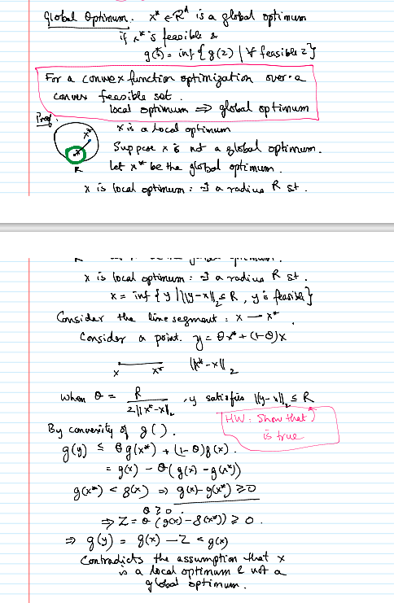

***Statement:***

For the optimization of a convex function over a convex feasible set, local optimum = global optimum. x is a local optimum. Suppose x is not a global optimum. Let x* be the global optimum. x is a local optimum.... x = inf {y | ||y-x||| <= R, y is feasible}. Consider the line segment x --> x*. Consider a point y = tetha x* + (1-theta)x. when tetha = R ('radius') / (2 |||x* - x||), y satisfies ||y -x|| <= R... prove that: y satisfies ||y -x|| <= R → IS TRUE.

***Solution:***

We have to show that ||y - x|| ≤ R, where y = θx* + (1 - θ)x, θ = R/(2|||x* - x||), and x* is the global optimum.

First, note that |||x* - x|| > 0 since x is a local but not global optimum, and x* is the global optimum.

Next, we have:

||y - x|| = ||θx* + (1 - θ)x - x|| = ||θ(x* - x)|| = θ ||x* - x||.

Substituting θ = R/(2|||x* - x||), we obtain:

||y - x|| = (R/(2||x* - x||)) ||x* - x|| = R/2 < R

Therefore, y satisfies ||y - x|| <= R, which completes the proof.

***HW7: L8 - page 1***

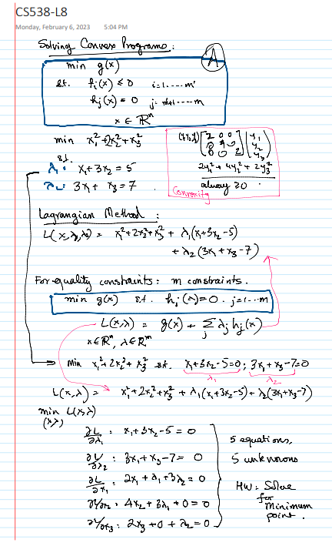

***Statement:***

We have the following system of equations:

dL/dλ1 = 0 = x1 + 3*x2 - 5

dL/dλ2 = 0 = 3*x1 + x3 - 7

dL/dx1 = 0 = 2*x1 + λ1 + 3*λ2

dL/dx2 = 0 = 4*x2 + 3*λ1

dL/dx3 = 0 = 2*x3 + λ2

***Solution:***

Using the fourth equation, λ1 can be solved in terms of x2

dL/dx2 = 0 = 4*x2 + 3*λ1 => λ1 = -(4/3)*x2

With the fifth equation, λ2 can be obtained in terms of x3:

dL/dx3 = 0 = 2*x3 + λ2 => λ2 = -2*x3

Substituting these expressions into the third equation we get rid of the lambda parameters:

dL/dx1 = 0 = 2*x1 - (4/3)*x2 - 6*x3

Now obtaining x1 as a function of x2, x3

2*x1 = (4/3)*x2 + 6*x3 => x1 = (2/3)*x2 + 3*x3

Substituting these expressions for x1, λ1 , λ2 into the first equation, we obtain:

dL/dλ1 = 0 = (2/3)*x2 + 9*x3 - 5… if we keep operating between equations, we just solve the feasible system of 5 equations and 5 variables, whose results are as follows:

The minimum point of the function is:

***x1*** = ***2.16***

***x2*** = 87 / 92 = ***0.94***

***x3*** = 47 / 92 = ***0.51***

***λ1*** = -(29 / 23) = ***- 1.26***

***λ2*** = -(47/46) = ***- 1.02***

***HW8: L9 - page 4***

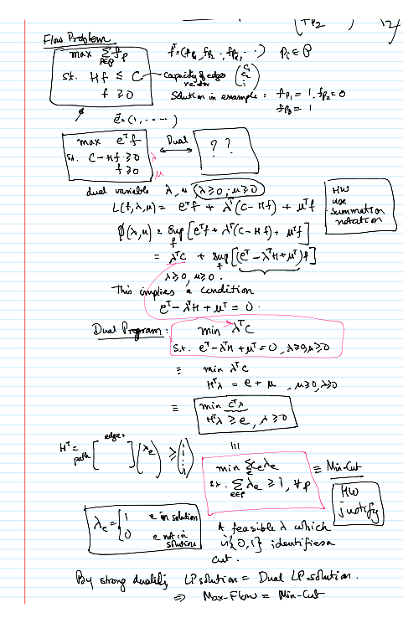

1. ***Statement:***

Use the summation notation for representing the next equation:

***L(f, λ, ν) = fᵢ + (c - H f) + f***

1. ***Solution:***

The flow problem with the given function can be expressed using the summation notation as follows:

***L(f, λ, ν) = Σᵢ φᵢ fᵢ + Σⱼ λⱼ(cⱼ - Σᵢ Hⱼᵢ fᵢ) + Σᵢ νᵢ fᵢ***

Where:

Σᵢ denotes the sum over all indices i.

Σⱼ is the sum over all indices j.

φ is a vector of coefficients of the flux variable f.

λ is a vector of Lagrange multipliers associated with the constraint c - Hf = 0.

ν is a vector of Lagrange multipliers associated with the nonnegativity constraint of f.

c is a vector of constants.

H is a matrix of coefficients.

f is the flux variable.

Note that the dot product between two vectors can be expressed using summation notation as Σᵢ xᵢyᵢ. In this case, Σᵢ φᵢ fᵢ represents the scalar product between the vectors φ and f. Similarly, Σᵢ Hⱼᵢ fᵢ represents the scalar product between the j-th row of H and f.

1. ***Statement:***

Justify that the min cut problem is the dual of the flow problem

***2) Solution:***

***The duality of the flow problem:***

The flow problem can be expressed mathematically as follows:

Maximize Z = ∑ fij, i, j ∈ N.

***Subject to:***

fij ≤ cij for all i, j ∈ N.

∑ fij - ∑ fji = 0 for all i ∈ N

0 ≤ fij ≤ uij for all i, j ∈ N

where fij represents the flow from node i to node j, cij represents the capacity of the edge between nodes i and j, and uij represents the upper bound of the flow between nodes i and j. The objective function Z represents the total flow over the network of N nodes.

On the other hand, the min cut problem can be expressed mathematically as follows:

Minimize Z = ∑ cij, i, j ∈ N.

***Subject to:***

Si ⊆ N, Ti ⊆ N, Si ∩ Ti = ∅, and |Si| > 0, |Ti| > 0.

∑ fij - ∑ fji = 0 for all i ∈ N

fij ≤ cij for all i, j ∈ N

fij ≥ 0 for all i, j ∈ N

where Si and Ti represent two disjoint sets of nodes partitioning the network, and cij represents the cost of cutting the edge between nodes i and j. The objective function Z represents the total cost associated with splitting the network into two parts.

The min cut problem is the dual of the flow problem due to the fact that the two problems are related through duality: any feasible flow in the flow problem can be represented as a cut in the min cut problem, and any network cut can be represented as constraints in the flow problem.

The flow problem is a linear programming problem in which flow variables must be limited so that the total flow over a network of nodes can be maximized. In contrast, the min cut problem seeks to minimize the total cost of dividing the network into two parts within certain cut variables constraints.

The duality of the two problems makes it possible to resolve one by resolving the other's dual, or the other way. This tool is really helpful because sometimes, the dual problem is easier than the main one. Despite the fact that they are connected by duality, it is important to note that the approaches to solving these problems may be different.